**KILLI**

**GANESH**

E

**-**

mail**:**

ganeshkilli052@gmail.com

Contact: +91 6304837203

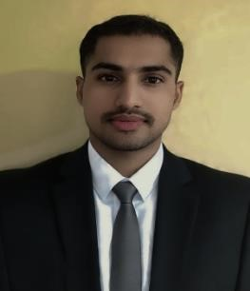

**Career Objective**

To seek a challenging job in the growth-oriented organization, where I could unleash my skills and abilities with mutual growth prospective with my potential exposure.

**Educational Qualifications**

|  |  |  |  |  |
| --- | --- | --- | --- | --- |
| **Qualification** | **Institute** | **University** | **Year of Passing** | **Percentage** |
| Bachelor of Hotel Management | Sun International Institute of Tourism and Management | Andhra University | 2022 | 74.5% |
| Intermediate | M.V.R. Junior College | Board of Intermediate Education Andhra Pradesh | 2019 | 63.5% |
| SSC | Andhra Pradesh Model School | Board of Secondary Education | 2016 | 9.0 GPA |

**Technical Skills**

* MS Word
* MS Office

**Strengths**

* Good at communication Skills
* Handwriting
* Quick Learner
* Positive Attitude
* Patience

**Hobbies**

* Listening Music
* Browsing Internet

**Work Experience**

* Internship worked as Industrial Trainee Radisson HITEC City in Hyderabad from 15th January 2022 to 16th June 2022
* Worked as a Guest Service Associate (GSA) in Radisson HITEC City Hyderabad from 21st June 2022 to 25th June 2023
* Worked as Guest Service Associate in FOUR POINTS BY SHERATON in Visakhapatnam from 4th July 2023
* Currently working as a Team Lead in FOUR POINTS BY SHERATON in Visakhapatnam from 5th May 2025

**Awards and Achievements**

* Nominated 2 times as Associate of the month.
* Nominated as Associate of the Quarter 2023
* Received Appreciation letters couple of times

**Personal Information**

Full Name : Killi Ganesh

Father’s Name : Killi Ramu

Mother’s Name : Killi Lakshmi

Date of Birth : 15 June 2001

Gender : Male

Nationality : Indian

Languages Known : English, Hindi, Telugu

Address : (102) Ramakovila Street, Cheedikada, Anakapalli

531028, Andhra Pradesh, India

**Declaration**

I hereby declare that the above written particulars are true to the best of my knowledge and belief

**Killi Ganesh**

**Date:**

**Place: Visakhapatnam**